Name:………………………………………………..…. Date:………………………………………………………

Crystal chemistry

What is a crystal?
Crystals have been known as beautiful substances for thousands of years. Precious stones, like rubies, emeralds, diamonds and sapphires, have been traded for centuries at high values, because they are both beautiful and rare. Other crystals like salt and quartz (sand) are used everyday. Scientists have found out that body chemicals like DNA and proteins can be made into crystals. The invention of liquid crystals changed the way we tell the time.
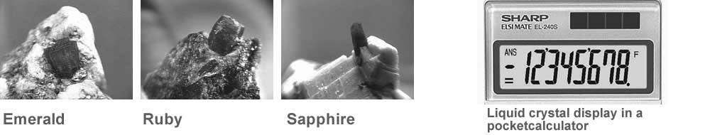
Reproduced with kind permission of Amethyst Galleries Inc. http://mineral .galleries.com | Reproduced with kind permission of Sharp Consumer Electronics
Find out the differences between crystals and substances which are not crystals in this experiment. Look carefully at the substances using a hand-lens.
What you need
- Hand-lens
- Samples of solid substances.

What you do
1. To start, write down:
- what you think a 'crystal' is - try to be scientific!
- names of substances which may be crystals.
2. Now make a table with these four columns:
- Substance name
- Colour
- Appearance
- Crystal
- Yes/No?
3. Allow about ten rows to complete the table.
4. Using the hand-lens, look at as many solid substances as possible. Write down the name of each substance in the table. Put the colour next, then describe its appearance. Finally decide if the substance is a crystal or not.
continued on next page



Crystal chemistry
continued from previous page

Questions
1. How did you decide if something is a crystal or not?
……………………………………………………………………………………………………………….……………………………………………………………………………………………………………….
……………………………………………………………………………………………………………….2. Which everyday substances are crystals?
……………………………………………………………………………………………………………….……………………………………………………………………………………………………………….
……………………………………………………………………………………………………………….
3. Which of the substances you named at the start are crystals? Were you right or wrong about them?
……………………………………………………………………………………………………………….……………………………………………………………………………………………………………….
……………………………………………………………………………………………………………….
4. Name one feature common to all crystals.
……………………………………………………………………………………………………………….……………………………………………………………………………………………………………….
……………………………………………………………………………………………………………….
5. Why do crystals have different shapes?
……………………………………………………………………………………………………………….……………………………………………………………………………………………………………….
……………………………………………………………………………………………………………….
6. All the substances here are solids. What is a 'liquid crystal'? Can gases be crystals?
……………………………………………………………………………………………………………….……………………………………………………………………………………………………………….
……………………………………………………………………………………………………………….
7. How can a crystal be changed to being non-crystalline?
……………………………………………………………………………………………………………….……………………………………………………………………………………………………………….
……………………………………………………………………………………………………………….……………………………………………………………………………………………………………….……………………………………………………………………………………………………………….
……………………………………………………………………………………………………………….……………………………………………………………………………………………………………….

